Lab Assignment- 5.4
AI Assisted Coding
E Srivarsha
HTno– 2303A52343
Task 1:
Prompt: generate a Python script that collects user data (e.g., name, age, email). Then, ask Copilot to add comments on how to anonymize or protect this data.
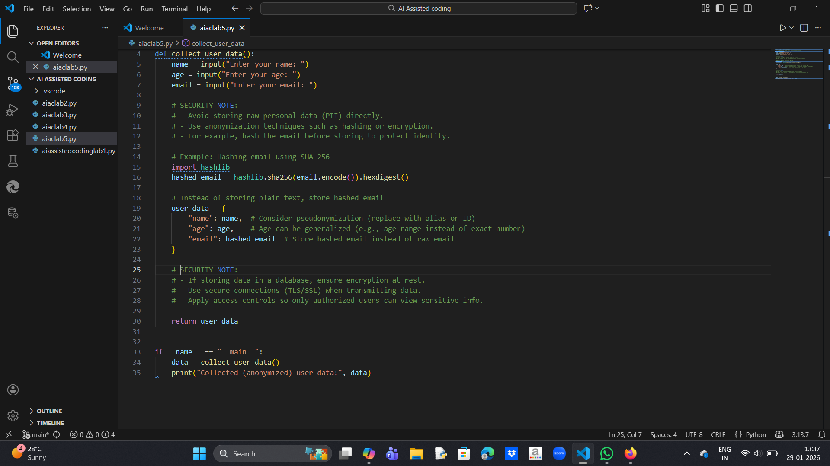
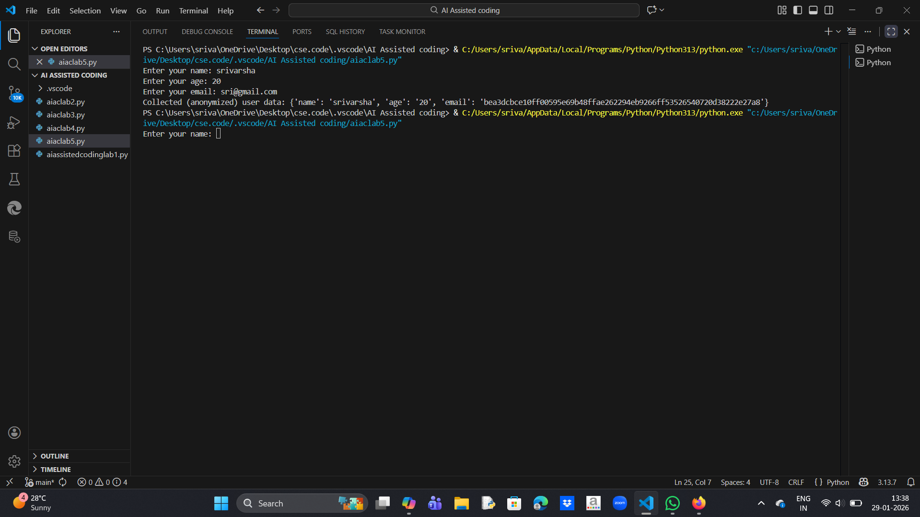

Explanation:
1.Personal data like email should never be stored in plain text
2.Hashing protects identity even if data is leaked
3.Developers should collect only required data
4.Sensitive data must be encrypted or anonymized
Task 2:
Prompt: Generate a Python function for sentiment analysis and identify potential biases in the data.

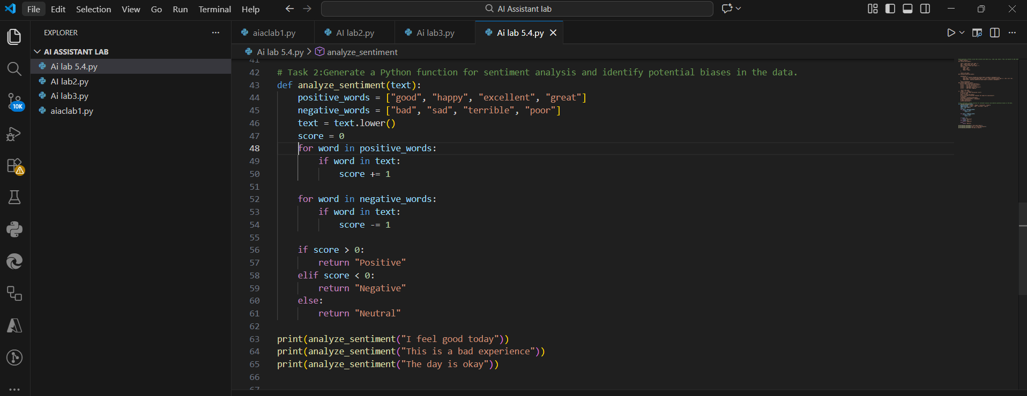
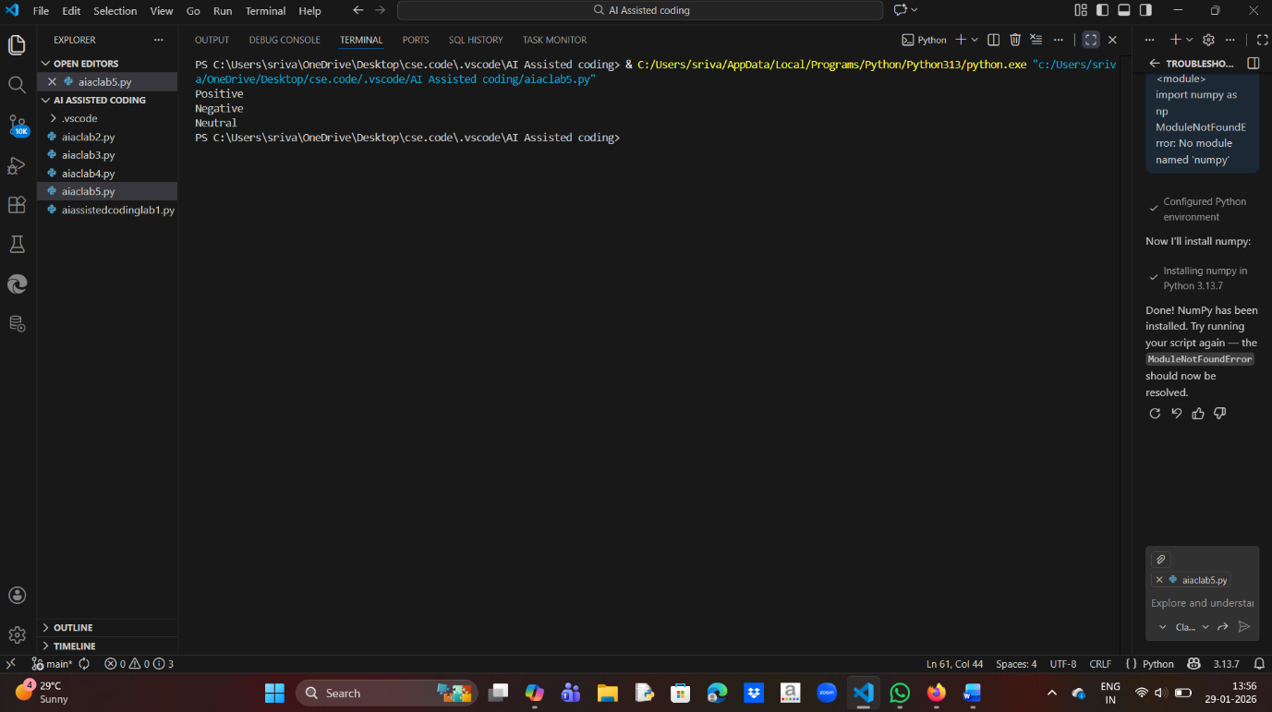

Explanation:
1. The sentiment analysis function classifies text as Positive, Negative, or Neutral.
2.AI-generated sentiment logic can be biased due to limited word lists.
3.A Neutral category is used to avoid forced or unfair classification.
4. Score-based evaluation improves fairness and reduces bias.
5.Human review is necessary to ensure ethical and responsible AI output.
Task 3:
Prompt: Generate a Python program that recommends products based on user history while following ethical guidelines like transparency and fairness.
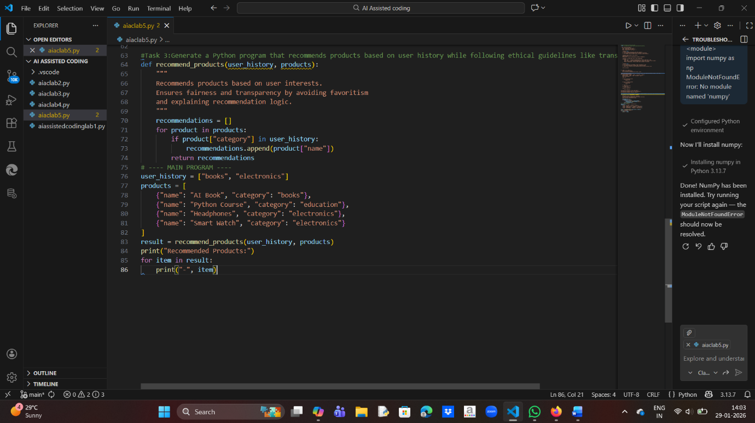
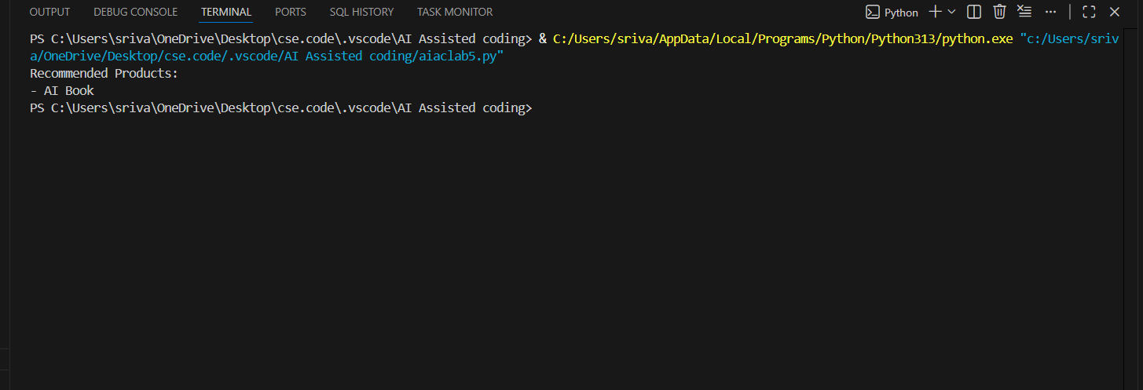

Explanation:
1. Recommendations are based only on user interests
2. No brand or price favoritism
3.Transparent logic (category matching)
4. User data is minimally used
Task 4:
Prompt: Generate logging functionality for a Python application and ensure that sensitive information is not recorded.
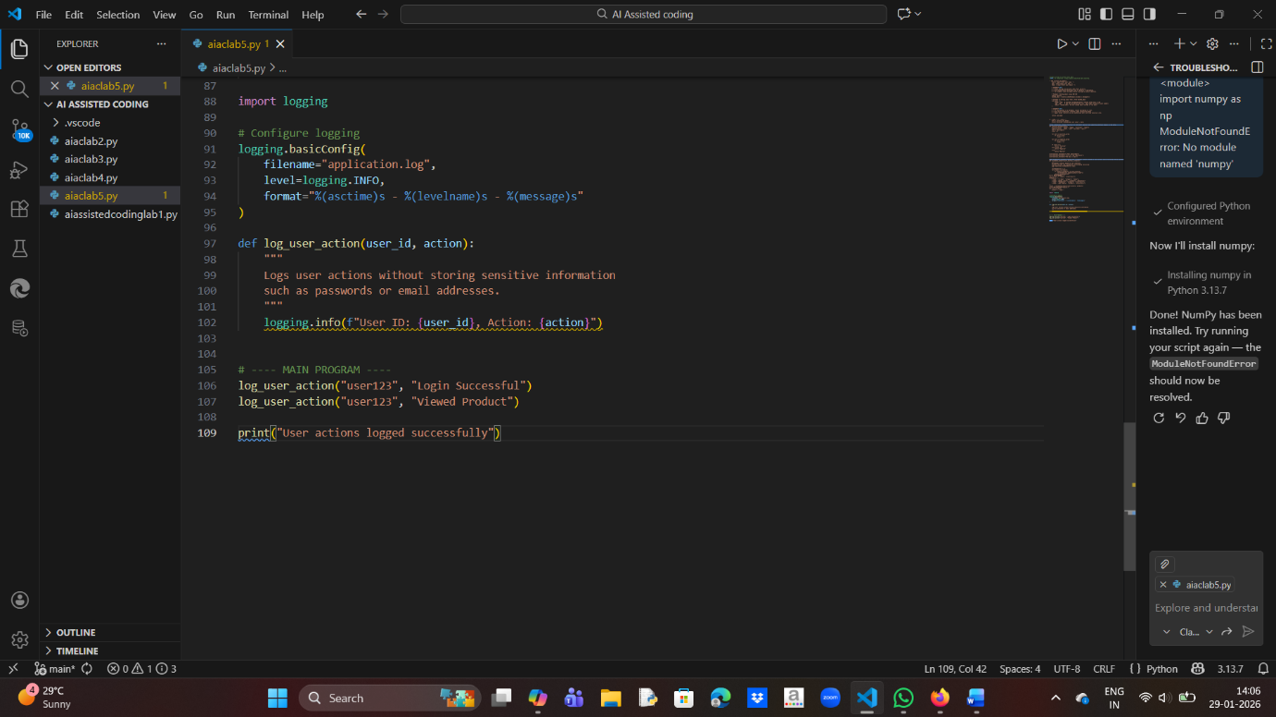
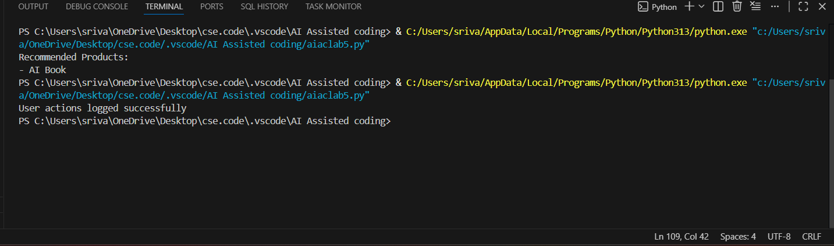

Explanation:
1.Sensitive data like passwords and emails are not logged
2.Uses anonymized user ID instead of personal details
3. Ensures transparency and privacy protection
4.Supports responsible AI and software practices
Task 5:
Prompt: Generate a simple machine learning model and add documentation explaining how to use the model responsibly.
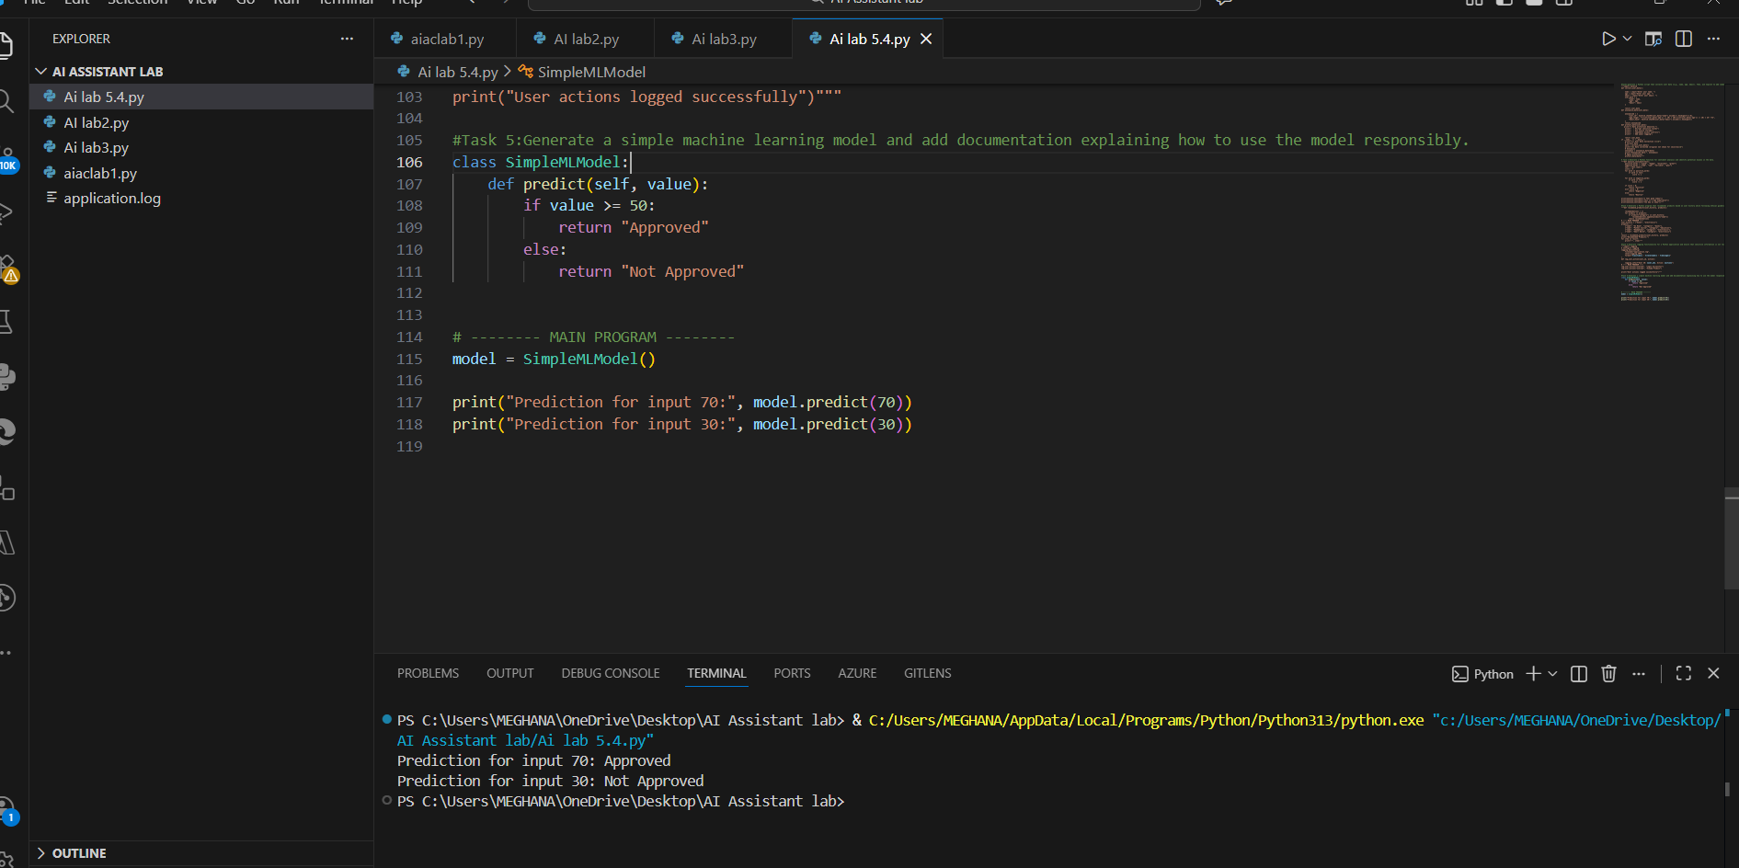
Explanation:
1. A simple model predicts “Approved” or “Not Approved” based on input value.
2.No real machine learning libraries are used, ensuring easy execution.
3.Predictions may be inaccurate and are for educational purposes only.
4.Bias may exist due to fixed rules, highlighting the need for human review.
5.Documentation ensures responsible and ethical AI usage.

